4CS001
Introductory Programming
&
Problem-Solving

Lab Report

Name: Sagar Mishra
Group: 4
Student ID: np02cs4a250038

Module Leader Tutor
_______________ ______________
Table of Contents
Lab | Lab Title | Page No. | Tutor’s Signature
3 | 1. Part 1 5  1.1 How can you use logical operators (AND, OR, NOT) to combine multiple conditions in a control flow statement, and what are some common use cases for this type of logic? 5  1.2 What is a "nested control flow statement," and how can you use it to create more complex logic in your program? 6  1.3 Describe the concept of "chaining" if-else statements together and explain the advantages and disadvantages of this approach over using nested if statements. 7  1.4 Explain the concept of "scope" in programming, and how it relates to control flow statements like "if-else". What is some common scope-related issues that can arise in programming, and how can you avoid or troubleshoot them? 8  1.5 Evaluate and write the output of the following expressions for num1 = 10 and num2 = 20. 9  (a) not (num1 < 1) and num2 < 10 9  (b) not (num1 < 1) and num2<10 or num1 + num2 < 100 9  (c) not (num2 > 1) or num1 > num2 – 10 9  2. Part 2 10  2.1 Develop a program that asks the user for a number and then displays whether the number is positive or negative. 10  2.2 Write a Python program that reads in two numbers and prints out whether their sum is even or odd. 10  2.3 Write a program to find the lowest number out of two numbers expected from the user. 11  2.4 Write a program to check whether a character is a vowel or consonant. [Expected from user’s input]. 11  2.5 Accept the age of 4 people and display the oldest one. 12  2.6 Write a program that takes three numbers as input and outputs the largest of the three numbers using if-else statements. For example, if the inputs are 4, 7, and 2, the program should output 7. 12  2.7 Write a Python program to calculate the difference between a given number and 17. If the number is greater than 17, return twice the absolute difference. 13  2.8 Give an appropriate if-statement for each of the following (the value of num is not important): 13  (a) Displays 'within range' if num is between 0 and 100, inclusive. 13  (b) Displays 'within range' if num is between 0 and 100, inclusive, and displays 'out of range' otherwise. 13  2.9 Rewrite the following if-else statements using a single if statement and elif: 14  3. Part 3 15  3.1 Write a program that takes the name and age of the user as input and displays a message whether the user is eligible to apply for a driving license or not. (The eligible age is 18 years). 15  3.2 Write a Python program that prompts the user to enter their weight in kilograms and their height in centimeters. The program should then calculate the user's BMI (Body Mass Index) using the formula: BMI = weight / height^2. The resulting BMI value should be printed to the console along with a message indicating whether the user is underweight (BMI < 18.5), normal weight (18.5 <= BMI < 25), overweight (25 <= BMI < 30), or obese (BMI >= 30). 16  3.3 Write a Python program to sum two given integers. However, if the sum is between 15 and 20 it will return 20. 17  3.4 Accept the marked price from the user and calculate the Net amount as (Marked Price - Discount) to pay according to the following criteria. 17  3.5 Accept the age and gender, number of days and displays the wages accordingly: 18  3.6 Write a Python program in which: 19  (a) The user enters either 'A', 'B', or 'C'. If 'A' is entered, the program should display the word 'Apple'; if 'B' is entered, it displays 'Banana'; and if 'C' is entered, it displays 'Coconut'. Use nested if statements for this. 19  (b) A student enters the number of college credits earned. If the number of credits is greater than or equal to 90, 'Senior Status' is displayed; if greater than or equal to 60, 'Junior Status' is displayed; if greater than or equal to 30, 'Sophomore Status' is displayed; else, 'Freshman Status' is displayed. 20  (c) The user enters a number. If the number is divisible by 3, the word ‘Fizz’ should be displayed; if the number is divisible by 5 the word ‘Buzz’ should be displayed and if the number is divisible by both ‘FizzBuzz’ should be displayed. 21  4. Part 4 22  4.1 Accept the electric units from the user and calculate the bill according to the following rates. 22  a) First 100 Units: Free 22  b) Next 200 Units: Rs. 2 per day. 22  c) Above 300 Units: Rs. 5 per day. 22  If number of units is 500 then total bill = 0 + 400 + 1000 = 1400 22  4.2 Write a program that takes n number as user input, which determines the size of the grid to be output e.g. 23  User_input = 10 23

Name / Sign of Module Leader Name / Sign of Module Leader

_________________ ___________________
Date: Date:

Part 1

How can you use logical operators (AND, OR, NOT) to combine multiple conditions in a control flow statement, and what are some common use cases for this type of logic?

- We can use logical operators to combine multiple conditions in control flow statement by using it as follows:
- AND:
We can use AND operator to run the control statement only when all the given conditions are true.
if age>18 and age< 32:
print ("You can enter the interview.")
In this program, user can only enter the interview if his age is between 18 – 32.

- OR:
We can use OR operator to run the control statement even if any one of the given conditions is true.
if drink == "Tea" or drink=="coffee"
print ("Hot drink selected.")
In this program, “Hot drink is selected.” will be printed when any one or both conditions are true.

- NOT:
We can use NOT operator to run the control statement when the given condition isn’t true.
is_logged_in = False
if not is_logged_in: #not is_logged_in= not False
print ("Please log in first.")
In this program, if user isn’t logged in, the screen will show “Please login first.”.

These operators are used when you need to check one or more conditions at a time to make decision. Logical operators are used to decide that a block of code will run when the condition is true.

What is a "nested control flow statement," and how can you use it to create more complex logic in your program?

- When we put a control flow statement inside another control flow statement, then it is a nested control flow statement. We can use it to handle more detailed situations and check conditions step by step. It is used to create more complex logic by validating user’s inputs step by step.
age = 20
ticket = True

if age >= 18: # First condition
print("You are old enough for entry.")

if ticket: # Second condition inside the first one
print("You may enter the movie theater!")
else:
print("Sorry, you need a ticket to enter the movie theater.")
else:
print("You are not allowed to enter as u are below legal age category.")

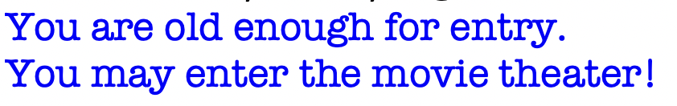

Describe the concept of "chaining" if-else statements together and explain the advantages and disadvantages of this approach over using nested if statements.

- Chaining means using if, else-if(elif) and else statement one after another in a straight line where the program checks each condition one by one until it finds true one. For example:
marks = 75
if marks >= 90: #first check
print ("Grade A")
elif marks >= 80: #second check
print ("Grade B")
elif marks >= 70: #third check (true), exits
print ("Grade C")
else:
print("Fail")
Advantages:
- Condition is checked one after another until its true rather than being one in another like in nested control flow statement.
- Good for choosing one option among many possibilities.
- Easier to understand as it is in a straight line.
- Execution time is less than nested.

Disadvantages:

- Not for decisions when it depends on multiple related conditions.
- Not suitable when u need one if inside another.
- Good for one selection but not for step by step checking like in nested.

Explain the concept of "scope" in programming, and how it relates to control flow statements like "if-else". What is some common scope-related issues that can arise in programming, and how can you avoid or troubleshoot them?

- Scope means the area of any variable where it can be accessed inside a program. Scope is of two types global and local. In python, a variable can be that is created globally can be used anywhere in the program which is global scope. Local scope in python means a variable created inside a function can only be accessed inside that function only.

Wrong way:
x = 14
if x< 13:
output = "smaller"
print(output)

Correct way:
x =14
if x< 13:
output = "smaller"
else:
output = "greater"
print(output)



Wrong way
print(a)
a=12
Correct way
a=12
print(a)

Evaluate and write the output of the following expressions for num1 = 10 and num2 = 20.

not (num1 < 1) and num2 < 10

- num1 = 10
num2 = 20
not (num1 < 1) = not(10 < 1) = True
num2 < 10 = 20 < 10 = False
Output = True and False = False

not (num1 < 1) and num2<10 or num1 + num2 < 100

- num1 = 10
num2 = 20
not (num1 < 1) = not (10 < 1) = True
num2 < 10 = 20 < 10 = False
num1 + num2 < 100 = 10 + 20 < 100 = 30 < 100 = True
Output = True and False or True = False or True = True

not (num2 > 1) or num1 > num2 – 10

- num1 = 10
num2 = 20
not (num2 < 1) = not (20 < 1) = True
num1 > num2 – 10 = 10 > 20 – 1 = 10 > 10 = False
Output = True or False = True

Part 2

- Develop a program that asks the user for a number and then displays whether the number is positive or negative.

- Code:
num = int (input ("enter the number:"))
if num<0:
print ("Negative.")
else:
print ("Positive.")
- Output:
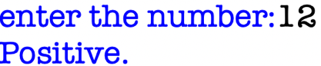

- Write a Python program that reads in two numbers and prints out whether their sum is even or odd.

- Code:
num1=int (input ("enter the first number:"))
num2=int (input ("enter the second number:"))
if (num1+num2) %2 == 0:
print (f"The sum is even.\n {num1+num2}")
else:
print (f"The sum is odd.\n {num1+num2}")
- Output:
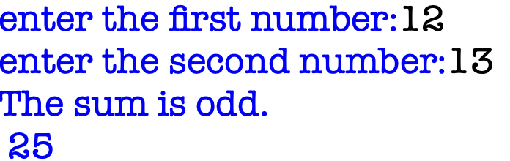

- Write a program to find the lowest number out of two numbers expected from the user.

- Code:
num1 = int (input ("Enter the first number:"))
num2 = int (input ("Enter the second number:"))
if num1<num2:
print (num1)
else:
print (num2)
- Output:
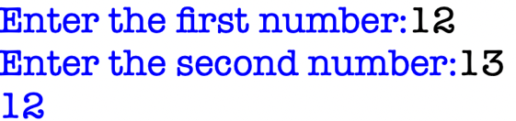

- Write a program to check whether a character is a vowel or consonant. [Expected from user’s input].

- Code:
char = str (input ("enter a single character:"))
char = char.lower()
if char in "aeiou":
print ("Vowel")
else:
print ("Consonant")
- Output:


- Accept the age of 4 people and display the oldest one.

- Code:
age = []
for i in range (1,5):
age_person = int (input (f"enter the number of person {i}:"))
age.append(age_person)
oldest = max(age)
person = age.index(oldest) + 1
print (f"Person {person} is oldest and {oldest} years old.")
- Output:
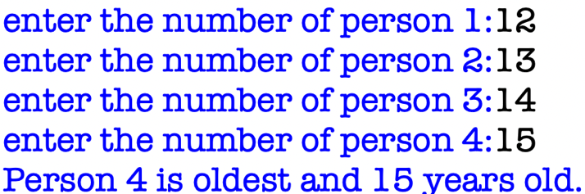

- Write a program that takes three numbers as input and outputs the largest of the three numbers using if-else statements. For example, if the inputs are 4, 7, and 2, the program should output 7.

- Code:
num1 = int (input ("enter the first number:"))
num2 = int (input ("enter the second number:"))
num3 = int (input ("enter the third number:"))
if num1>num2 or num3>num2:
if num1>num3:
print (num1)
else:
print (num3)
else:
print (num2)
- Output:
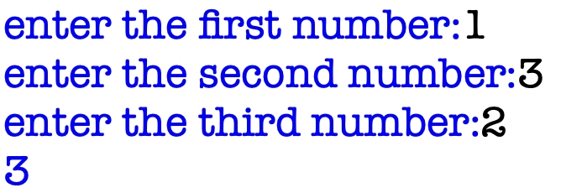

- Write a Python program to calculate the difference between a given number and 17. If the number is greater than 17, return twice the absolute difference.

- Code:
num = int (input ("Enter the number:"))
if num>17:
print (f"{(num - 17) * 2}")
else:
print (f"{17 - num}")
- Output:
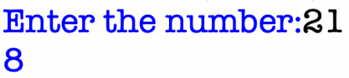
- Give an appropriate if-statement for each of the following (the value of num is not important):

- Displays 'within range' if num is between 0 and 100, inclusive.

- Code:
if num>=0 and num<=100:
print (“within range.”)

(b) Displays 'within range' if num is between 0 and 100, inclusive, and displays 'out of range' otherwise.

- Code:
if num>=0 and num<=100:
print (“within range.”)
else:
print (“out of range”)

- Rewrite the following if-else statements using a single if statement and elif:

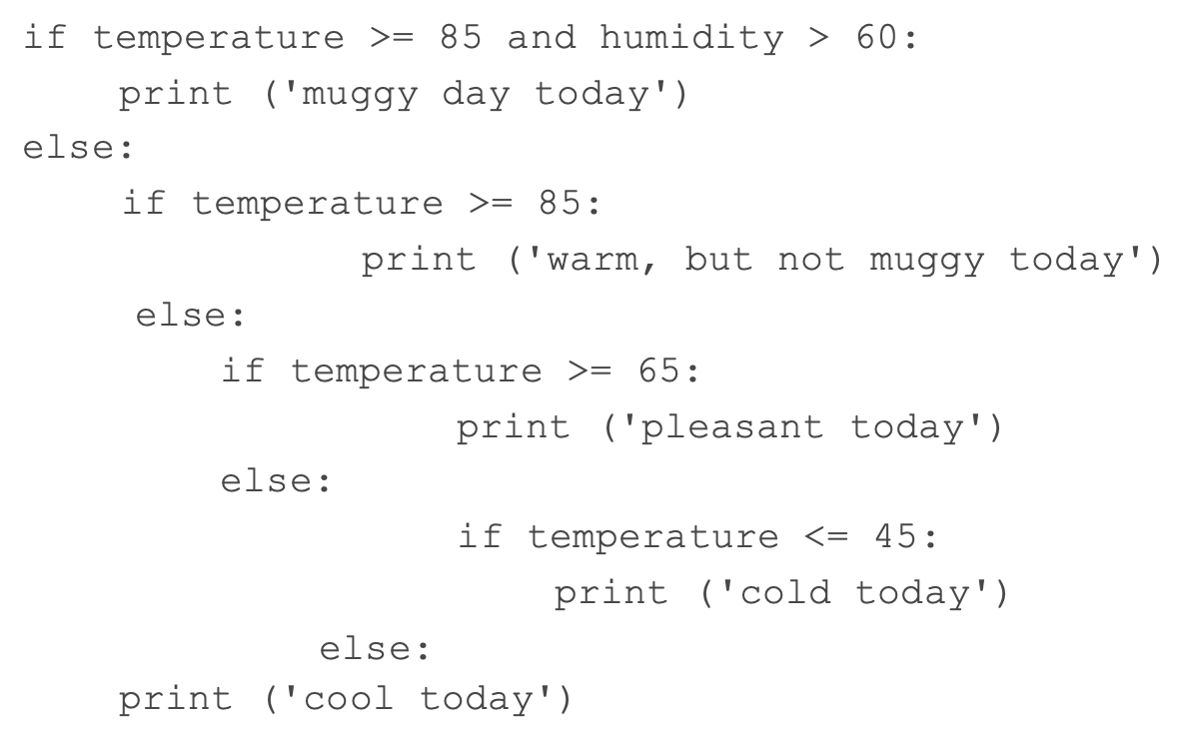

- Code:
if temperature>=85 and humidity > 60:
print (“muggy day today”)
elif temperature>=85:
print (“warm, but not muggy today”)
elif temperature>=65:
print (“pleasant today”)
elif temperature<=45:
print (“cold today”)
else:
print (“cool today”)

Part 3

- Write a program that takes the name and age of the user as input and displays a message whether the user is eligible to apply for a driving license or not. (The eligible age is 18 years).

- Code:
name = input ("enter the name:")
age = int (input ("enter your age:"))
if age >= 18:
print (f"{name} is elidglible for applying.")
else:
print (f"{name} is not elidglible for applying.")
- Output:
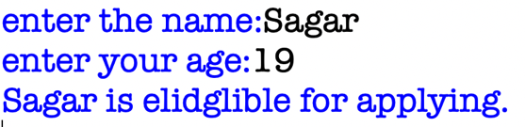

- Write a Python program that prompts the user to enter their weight in kilograms and their height in centimeters. The program should then calculate the user's BMI (Body Mass Index) using the formula: BMI = weight / height^2. The resulting BMI value should be printed to the console along with a message indicating whether the user is underweight (BMI < 18.5), normal weight (18.5 <= BMI < 25), overweight (25 <= BMI < 30), or obese (BMI >= 30).

- Code:
weight = float (input ("enter the weight in kilograms:"))
height = float (input ("enter the height in centimeters:"))
height = height/100
BMI = weight/(height**2)
print (f"{BMI:,.2f}")
if BMI<18.5:
print ("Underweight")
elif BMI < 25:
print ("Normal weight")
elif BMI < 30:
print ("Overweight")
else:
print ("Obese.")
- Output:
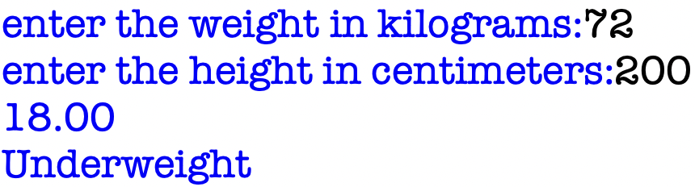

- Write a Python program to sum two given integers. However, if the sum is between 15 and 20 it will return 20.

- Code:
num1 = int (input ("Enter the first number:"))
num2 = int (input ("Enter the second number:"))
sum = num1 + num2
if sum>15 and sum<20:
print ("20")
else:
print (sum)
- Output:
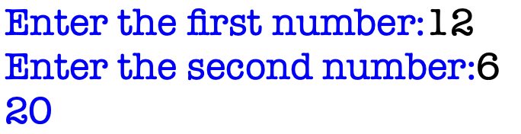
- Accept the marked price from the user and calculate the Net amount as (Marked Price - Discount) to pay according to the following criteria.
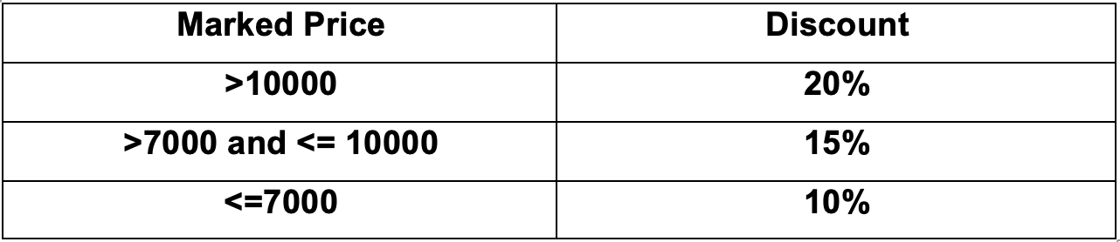
- Code:
MP = float (input ("Enter the marked price:"))
if MP>10000:
print (f"Net amount = {MP - (0.2 * MP):,.2f}")
elif MP>7000:
print (f"Net amount = {MP - (0.15 * MP):,.2f}")
else:
print (f"Net amount = {MP - (0.1 * MP):,.2f}")
- Output:
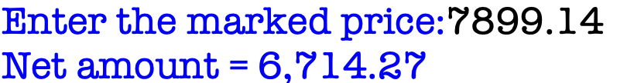

- Accept the age and gender, number of days and displays the wages accordingly:

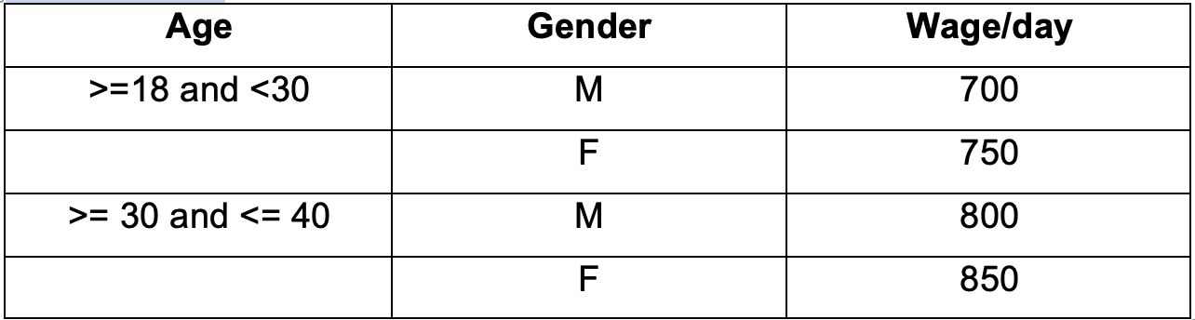
- Code:
age = int (input ("enter your age:"))
gender = input ("M for male \n F for female \n enter your gender:")
days = int (input ("Number of days you worked:"))
if age>=18 and age<30:
if gender == "M":
print (f" Wage = {700 * days}")
else:
print (f" Wage = {750 * days}")
elif age>=0 and age<=40:
if gender == "M":
print (f" Wage = {800 * days}")
else:
print (f" Wage = {850 * days}")
else:
print ("Not valid!")
- Output:
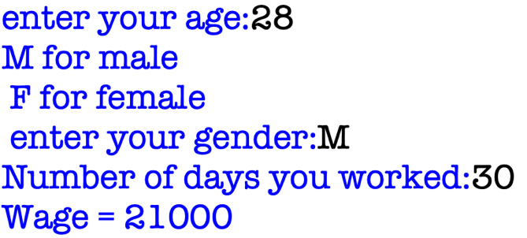

- Write a Python program in which:
- The user enters either 'A', 'B', or 'C'. If 'A' is entered, the program should display the word 'Apple'; if 'B' is entered, it displays 'Banana'; and if 'C' is entered, it displays 'Coconut'. Use nested if statements for this.

- Code:
abc = input ("Enter A, B, or C: ")
if abc == 'A':
print ("Apple")
else:
if abc == 'B':
print ("Banana")
else:
if abc == 'C':
print("Coconut")
else:
print ("Invalid input")
- Output:
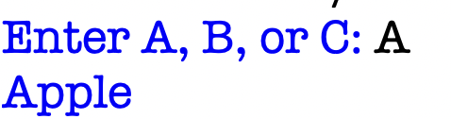
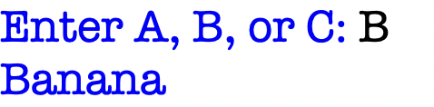
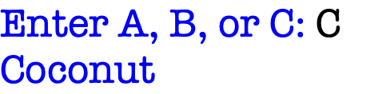

- A student enters the number of college credits earned. If the number of credits is greater than or equal to 90, 'Senior Status' is displayed; if greater than or equal to 60, 'Junior Status' is displayed; if greater than or equal to 30, 'Sophomore Status' is displayed; else, 'Freshman Status' is displayed.
- Code:
credit = int (input ("Enter your credit:"))
if credit>= 90:
print ("Senior status")
elif credit>=60:
print ("Junior status")
elif credit>=30:
print ("Sophomore status")
else:
print ("Freshman status")
- Output:

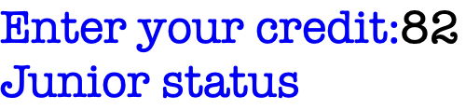

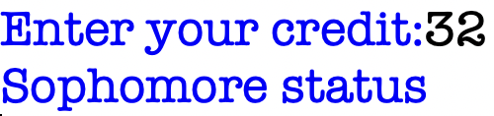
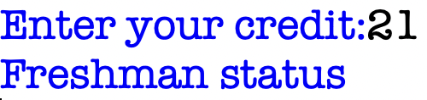

- The user enters a number. If the number is divisible by 3, the word ‘Fizz’ should be displayed; if the number is divisible by 5 the word ‘Buzz’ should be displayed and if the number is divisible by both ‘FizzBuzz’ should be displayed.

- Code:
num = int (input ("enter the number:"))
if num%3==0 and num%5==0:
print ("FizzBuzz")
elif num%3==0:
print ("Fizz")
elif num%5==0:
print ("Buzz")
else:
print ("not divisible by 3 or 5")
- Output:
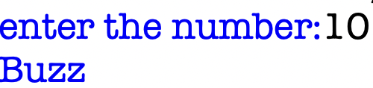
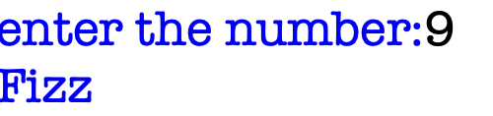
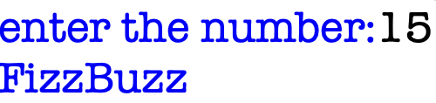

Part 4
- Accept the electric units from the user and calculate the bill according to the following rates.
- First 100 Units: Free
- Next 200 Units: Rs. 2 per day.
- Above 300 Units: Rs. 5 per day.

If number of units is 500 then total bill = 0 + 400 + 1000 = 1400

- Code:
unit = int (input ("Enter the number of electric units consumed: "))
bill = 0
if unit <= 100:
bill = 0
elif unit <= 300:
bill = (unit - 100) * 2
else:
bill = (200 * 2) + ((unit - 300) * 5)
print (f"Total electricity bill is: Rs.{bill}")
- Output:

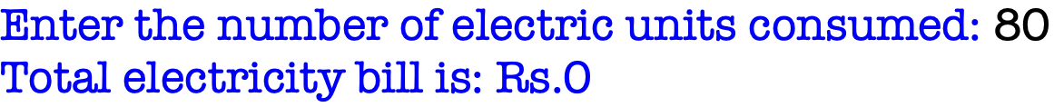

- Write a program that takes n number as user input, which determines the size of the grid to be output e.g.

User_input = 10
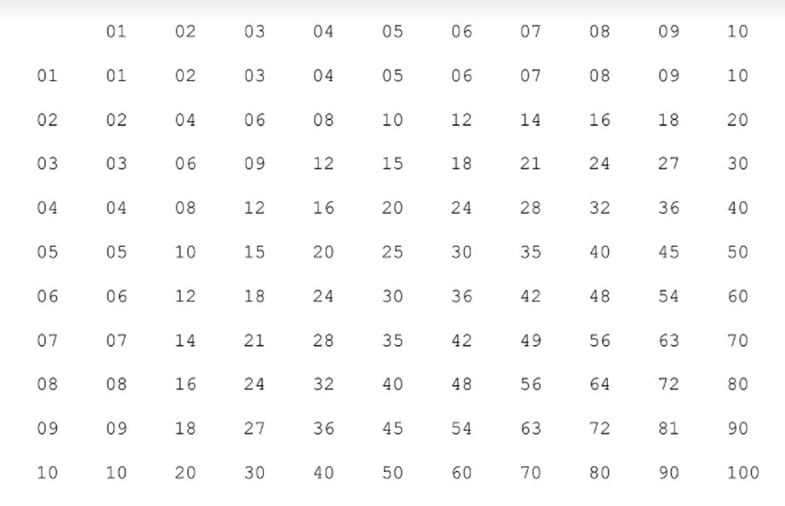

- Code:
n = int (input ("Enter the size of the grid: "))
print (" ", end="")

for i in range (1, n+1): #first row
print (f"{i:02}", end=" ")
print ()

for i in range (1, n+1): #other rows
print(f"{i:02}", end=" ")
for j in range (1, n+1):
print (f"{i*j:02}", end=" ")
print ()
- Output:
